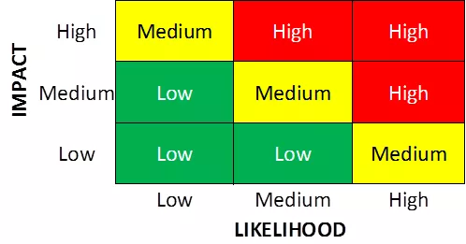

Risk, source, impact, likelihood, level, mitigation
Risk | Source | Impact | Likelihood | Level | Mitigation
Credential compromise | Default credentials | 2 - Medium | 1 - Low | 1.5 - Low | Change default credentials to complex credentials
Data Leak
Power outage
Phishing
Installed malware

